**TECHNICAL PROJECT REPORT**

# Title of Invention / Project:

# **ARTIFICIAL RAINBOW USING LED’S**

# Team Members / Inventors:

|  |  |  |  |  |  |  |
| --- | --- | --- | --- | --- | --- | --- |
| **S.No.** | **Name** | **Department** | **Designation** | **Mobile** | **E-Mail** | **Uid** |
| 1. | DUVVVI.KALYAN RAM | CSE IBM IS 2 | STUDENT | 9876847537 | [kalyanramduvvi@gmail.com](mailto:kalyanramduvvi@gmail.com) | 18BCS3576 |
| 2. | SARWARTH | CSE IBM IS 2 | STUDENT | 7018903525 | [Sarwarth2257@gmail.com](mailto:Sarwarth2257@gmail.com) | 18BCS3604 |
| 3. | DEEPAK JINDAL | CSE IBM IS 2 | STUDENT | 8447582138 | [Deepakreaper12@gmail.com](mailto:Deepakreaper12@gmail.com) | 18BCS3572 |
| 4. | RITIK MALHOTRA | CSE IBM IS 2 | STUDENT | 9057570969 | [Ritikmalhotra469@gmail.com](mailto:Ritikmalhotra469@gmail.com) | 18BCS3606 |
| 5. | ANSHULSHARMA | ECE | MENTOR | 9478697475 | [Anshulsharma.ece@cumail.in](mailto:Anshulsharma.ece@cumail.in) |  |
| 6. | KIRANJOT SINGH | ECE | MENTOR | 9463909689 | [Kiranjotsingh.ece@cumail.in](mailto:Kiranjotsingh.ece@cumail.in) |  |
| 7. | DIVNEET SINGH  KAPOOR | ECE | MENTOR | 9878422653 | [divneet.ece@cumail.in](mailto:divneet.ece@cumail.in) |  |

Section – 1 (IPR Related)

**Brief Abstract:** Artificial rainbow using led’s is used in decoration of house which is a very pleasant object to look at especially at night or in the dark. along with looking mood of an individual. the making of the artificial rainbow is very complex, it includes twenty eight led’s in which on the first line we have 3 led’s ,on second line we have 4 led’s , on third line we have 6 led’s ,on forth line we have 7 led’s , on fifth line we have 8 led’s connected in parallel connection together and whole lines of connection is connected in parallel connection and on end of every connection is connected to arduino and other end is connected to ground . The led’s when connected gives a look of a rainbow which is very applealing to look. Moreover, the LED’s come with a varity of colour scheams which are controlled by a Arduino uno.

# EXISTING STATE OF THE ART AND DRAWBACKS IN EXISTING STATE OF THE ART

|  |  |  |
| --- | --- | --- |
| SNO | EXISTING STATE OF ART | DRAWBACKS IN EXISTING STATE OF ART |
| 1. | dark light | some persons will use dim light’s |
| 2. | led’s are double time parallel connected | some persons will use both series and parallel connections |

# Novel/Additional modifications that you can propose to improve upon drawbacks

* re-apply the led’s neatly to make it more pleasing to look
* join the led’s in similar manner to make to see pleasent look and attractive.
* Keep the setting away from sunlight to look more beautiful.
* Keep the setting away from water as we are using current in this setting.

# Advantages

* pleasing to look at
* enhances the mood

Section – 2 (Real Project)

# MATERIAL :-

LED’S-28,PIECES , ARDUINOUNO , TRANSPARENT TUBE,WIRE ,ADOPTER, GUMTAPE , MALE TO MALE WIRE , MALE TO FEMALE WIRE , PACKING COVER , BREADBOARD , RESISTORS

|  |  |  |
| --- | --- | --- |
| s.no | material used | price |
| **1.** | **LED’S** | **56RS** |
| **2.** | **ARDUINO UNO** | **450RS** |
| **3.** | **TRANSPARENT TUBE** | **40RS** |
| **4.** | **WIRE** | **40RS** |
| **5.** | **ADOPTER** | **100RS** |
| **6.** | **MALE TO MALE WIRE** | **50RS** |
| **7.** | **MALE TO FEMALE WIRE** | **50RS** |
| **8.** | **COVERING PLASTIC COVER** | **20RS** |
| **9.** | **THERMACOAL** | **30RS** |
| **10.** | **BREAD BOARD** | **100RS** |
| **11.** | **RESISTORS** | **20RS** |

# Circuit Diagram OF LEDs:-

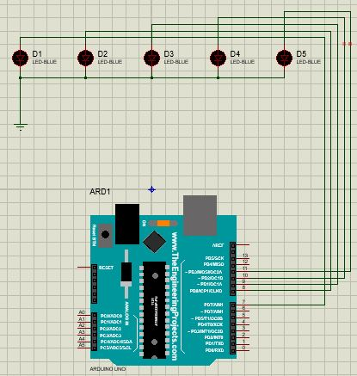

# PIN NUMBERS:-

1.the first line is connected to pin no :7

2. the second line is connected to pin no :8

3. the third line is connected to pin no :9

4. the fourth line is connected to pin no :10

5. the fifth line is connected to pin no :11

6. The other points of all are connected to ground

# Steps of Circuit Completion:-

1. we had taken twenty eight LED’S which are good working

2. we had inscribed eight LED’S which are connected parallel in a transparent tube.

3. similarly we had inscribed SEVEN LED’S,SIX LED’S,FOUR LED’S,THREE LED’S in the transparent tube which are connected parelley

4 .we had done a programming on LED’S by using proteus professional .

5. we inscribed that programming in Arduino uno and connected the LED’S to the Arduino uno

6. now we use the Arduino adopter for current supply to the Arduino uno and finally the led’s start running like a rainbow.

# **Program Code**

https://github.com/kalyanyadav1/artificial-rainbow.git